**Plotly Express Documentation**

**Step 1 -** Installing **plotly** module. You can do it inside Jupyter Notebook as shown below

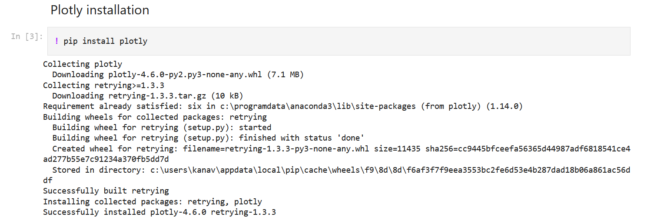

**Step 2 -** Reading the csv data into a dataframe.



**Step 3 -** Import required library - **plotly.express**



**Step 4 -** Scatter Plot using plotly.express

Note - Scatter Plot is a bivariate plot. Bivariate means it requires two variables / features / columns. You should make a note that both the variables should be real numerical valued.



**Step 5 -** Box Plot using plotly.express

Note - Box Plot can be used to create a univariate or bivariate plot. For a univariate box plot, the column type should be real numerical. For a bivariate box plot, one column should be categorical and another column should be real numerical. Below is an example of code for bivariate box plot.



**Step 6 -** Pie Chart Plot using plotly.express

Note - Pie Chart Plot can be used to create a bivariate plot. For a bivariate pie chart plot, one column should be categorical and another column should be real numerical. Below is an example of code for the plot.

names: It should be categorical column

values: It should be numeric column



**Step 7 -** Choropleth Plot using plotly.express

Note - Parameters for choropleth plot:

**locations**: It can be columns like - ‘Country’, ‘Zip Code’, etc..

**color**: It can be a column, value of which is used to assign color to marks

**locationmode**: It should be either one of ‘ISO-3’, ‘USA-states’, or ‘country names’. Determines the set of locations used to match entries in locations to regions on the map.

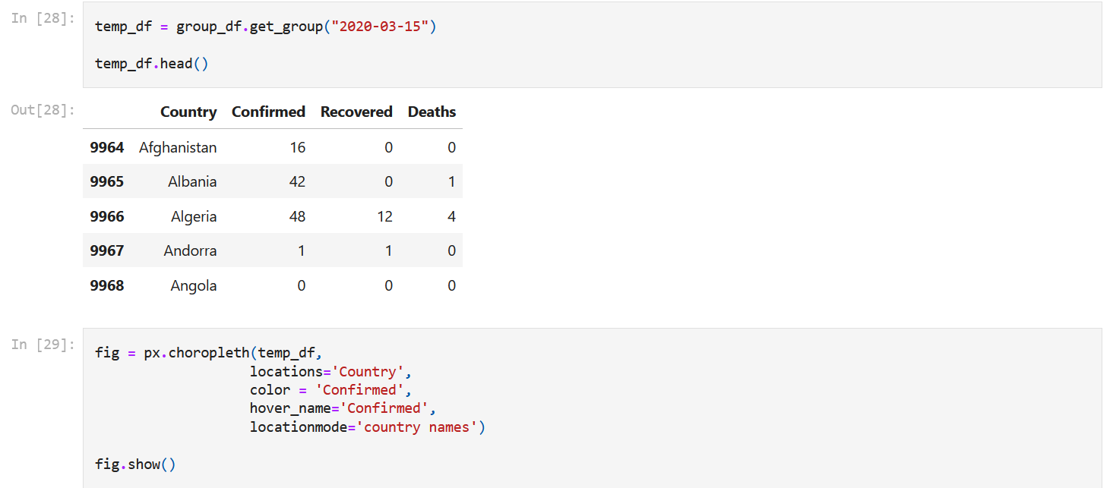

**Step 8 -** Animated Choropleth Plot using plotly.express

Note - Parameters for choropleth plot:

**animation_frame**: It should be a column like day, year, month, etc on which animation will be applied.

